**Back-end Tutorials**

1. How to change the Admin Panel Logins   
   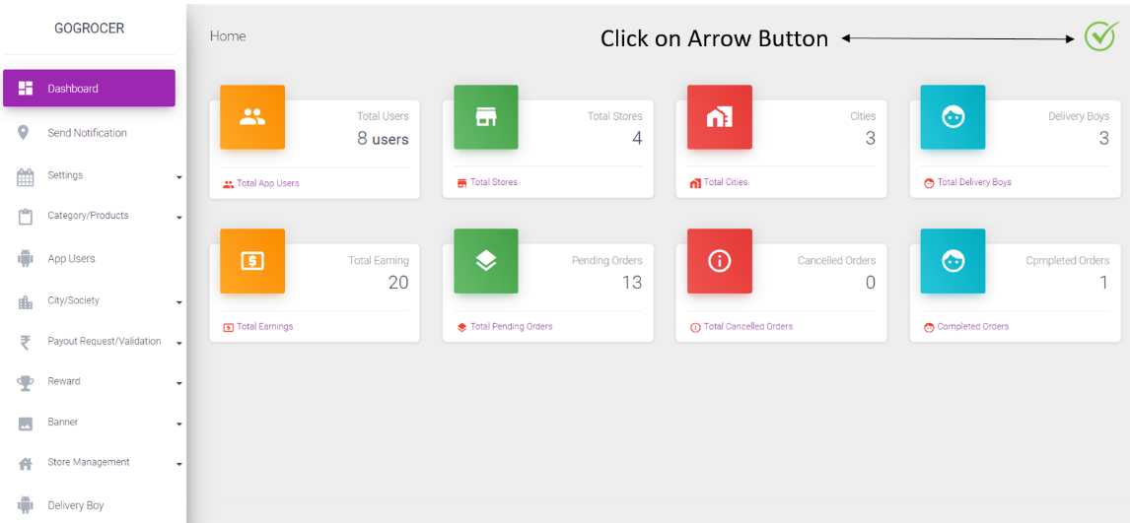

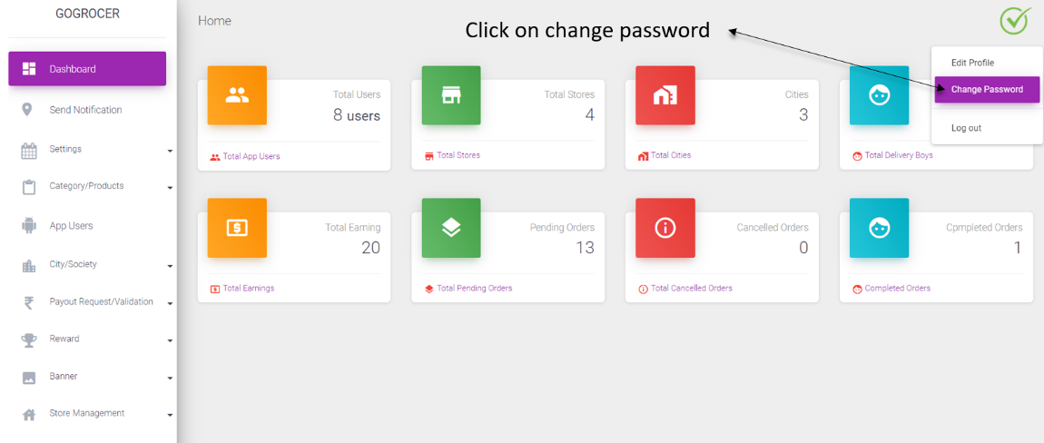

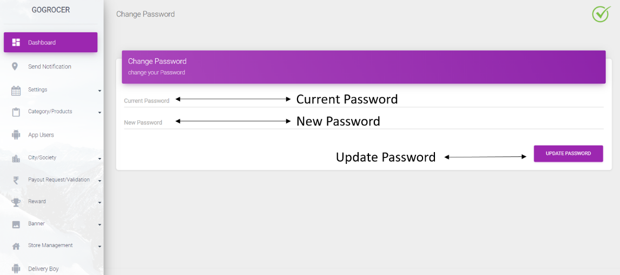

1. How to change Msg91, Google Map Api key

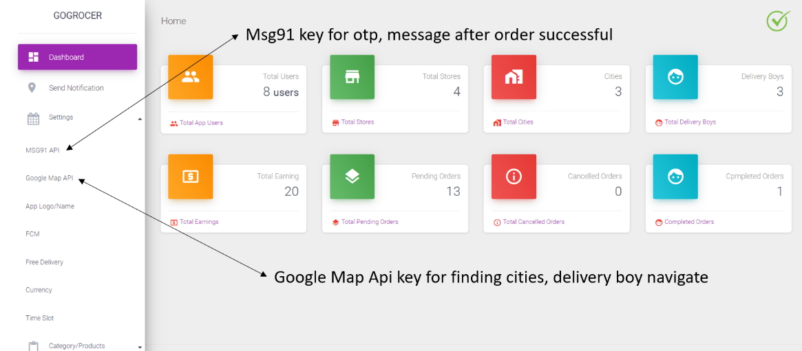

1. How to change App logo & Name

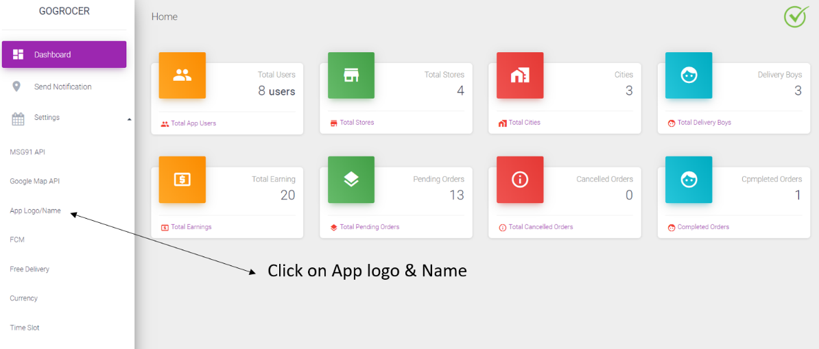

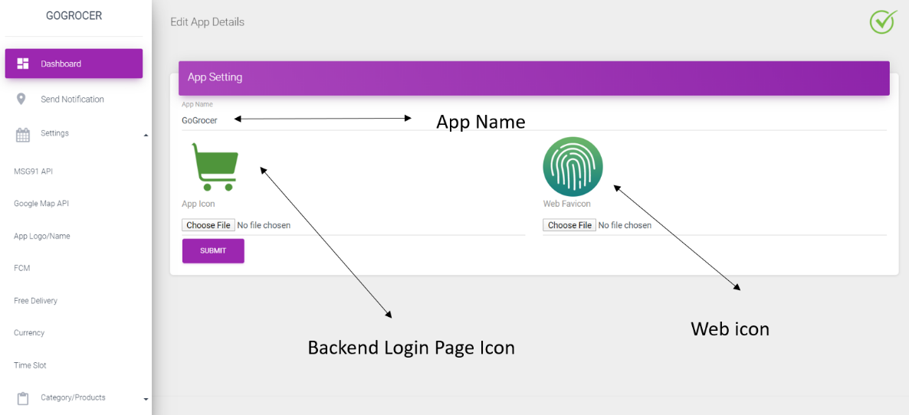

1. How to change FCM server key, click on sidebar FCM section

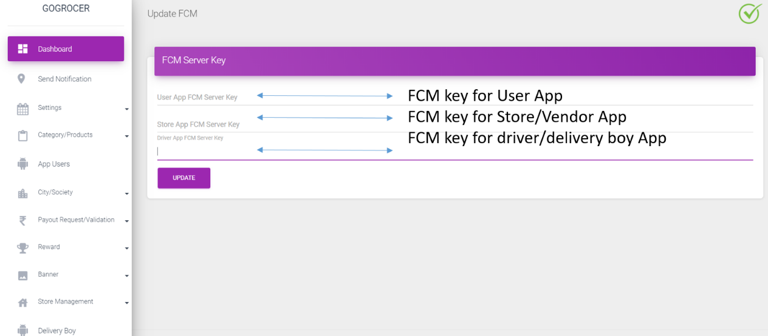

1. How to set delivery charges, time-slot & currency

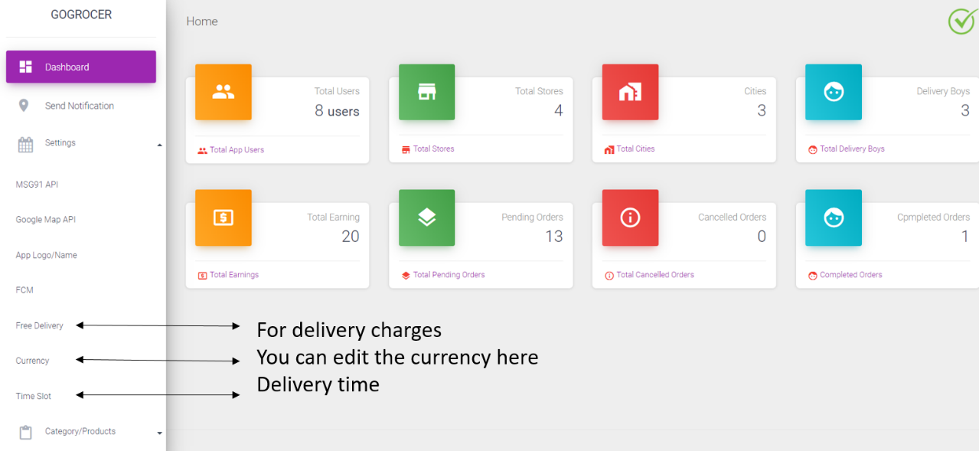

1. How to Add category & Product
2. In category section we add multi-level categories have a look

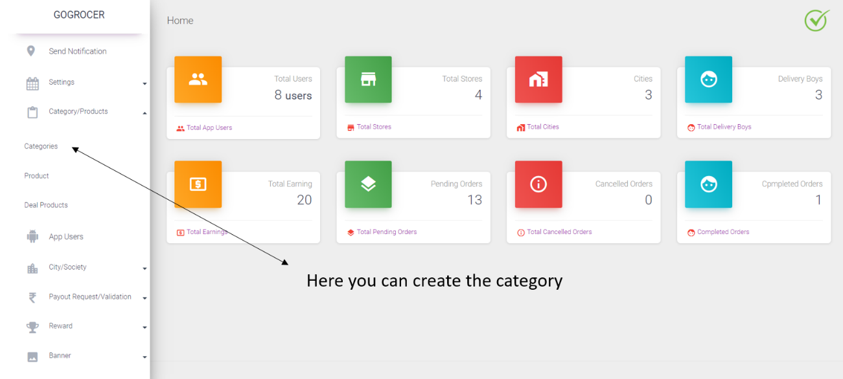

1. When you have click on add button you can see the

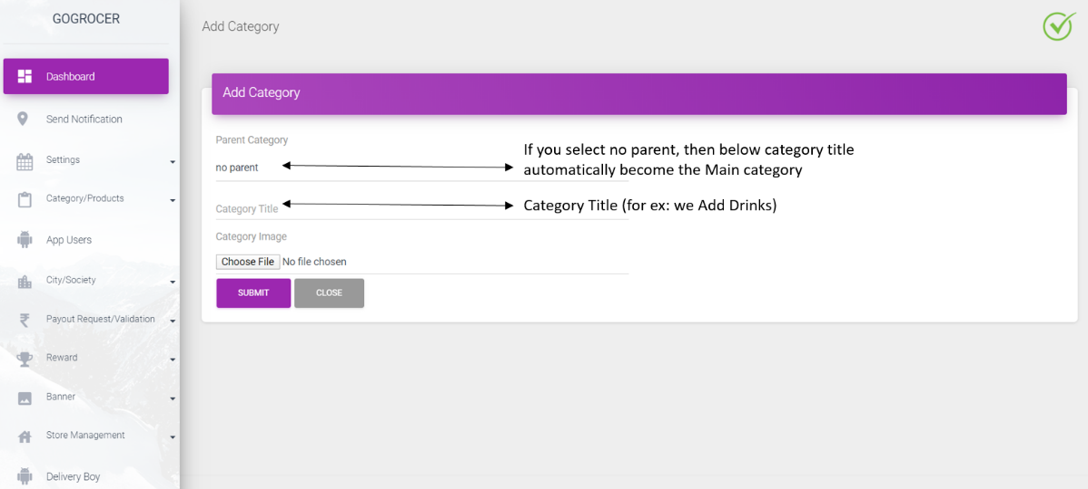

If you select no parent, then below category title automatically become the Parent category (look into the above picture we add a category **Drinks** as **parent** category)

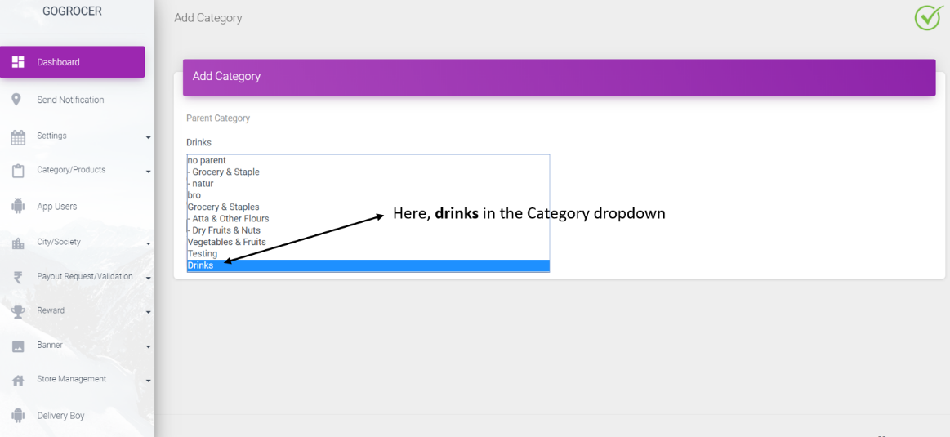

Now **Drinks** in the parent category drop-down (look into the above picture)

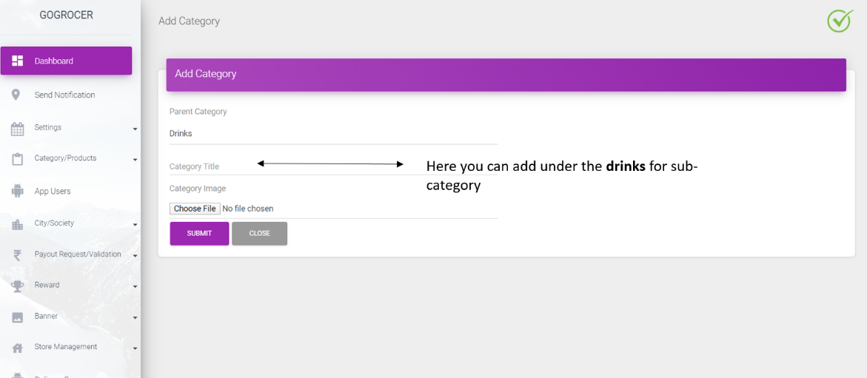

Now again you can added more **sub**-**categories** under **Drinks**

1. Products

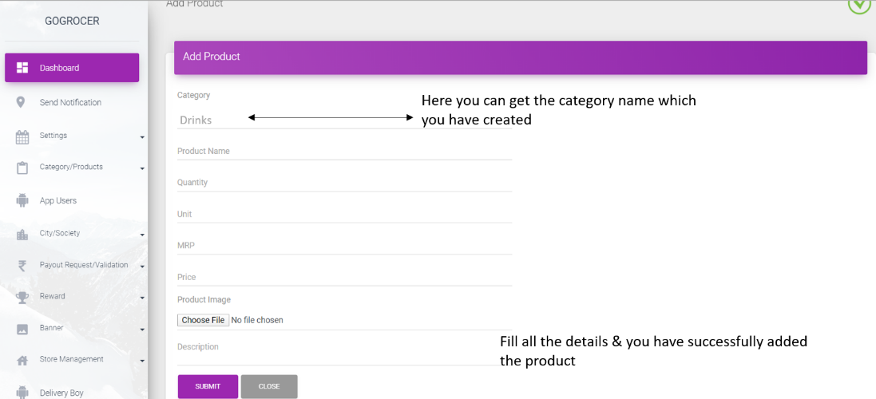

Choose the category **Drinks**, now add the product **Coca-Cola**, you have created so many products

1. Deals Product’s

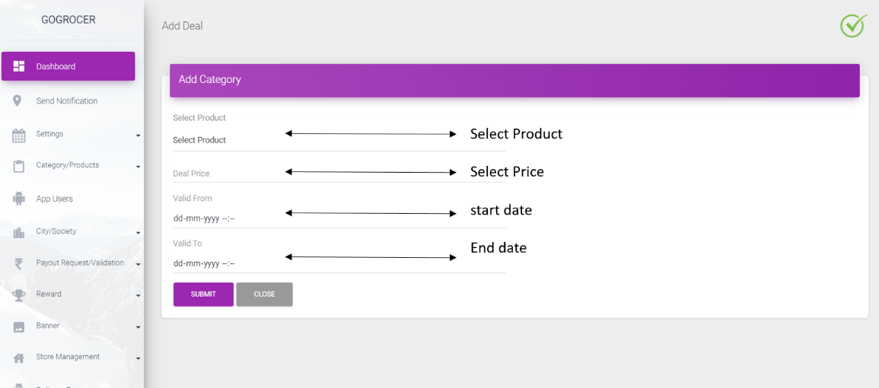

1. Payout Section

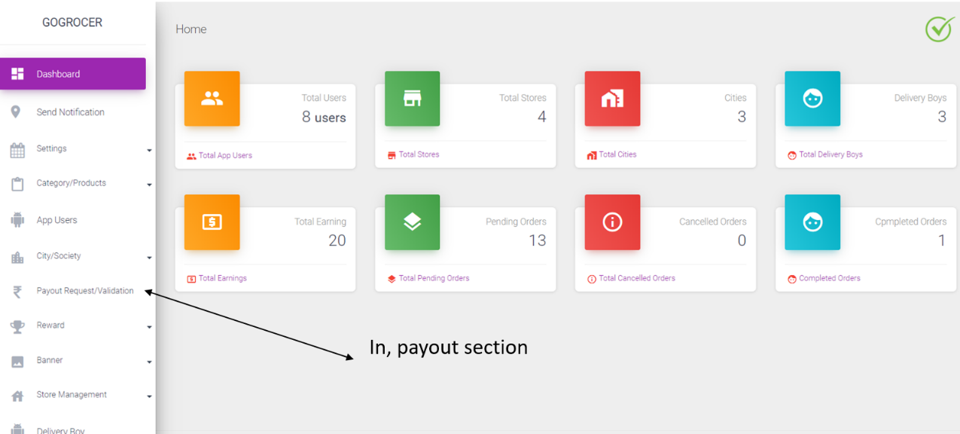

In payout section store will request the reaming amount to the Admin & admin will pay the amount directly here are the screenshots

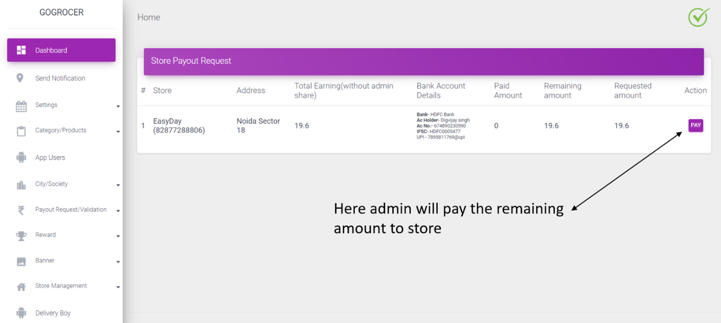

1. Reward Section

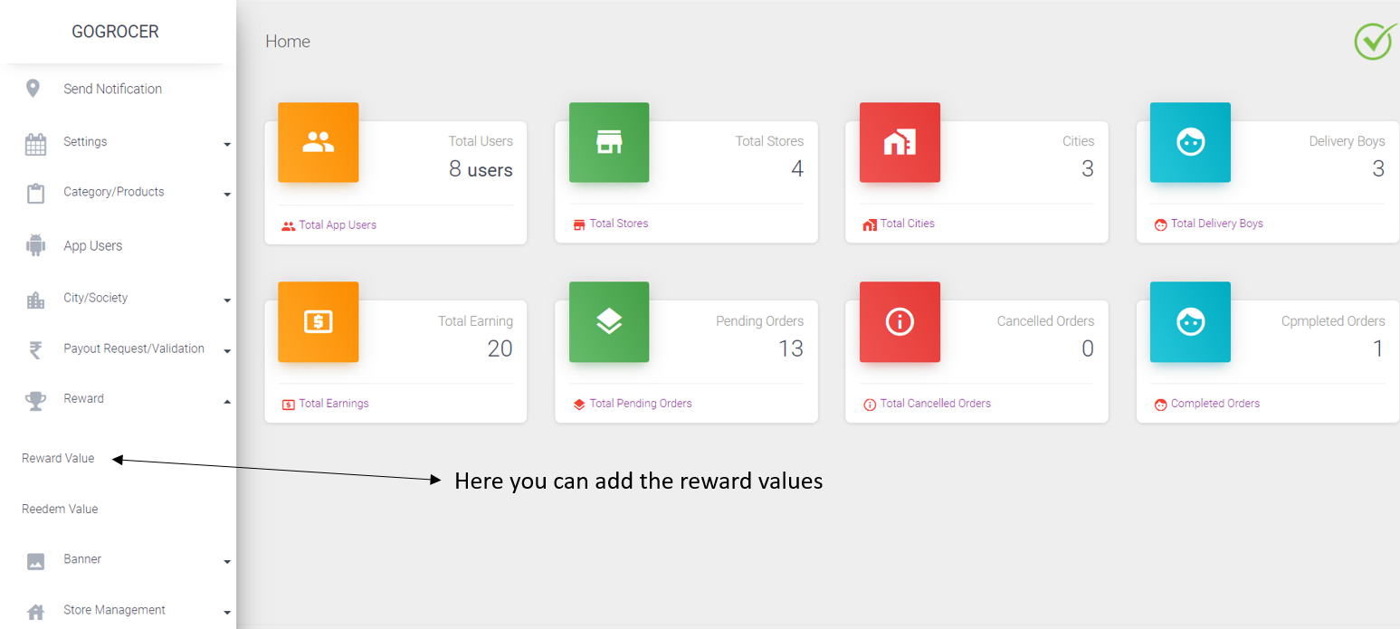

1. Reward points

Here you can add the cart value & the reward points (for ex: cart value 500 user will get the 10 rewards points)

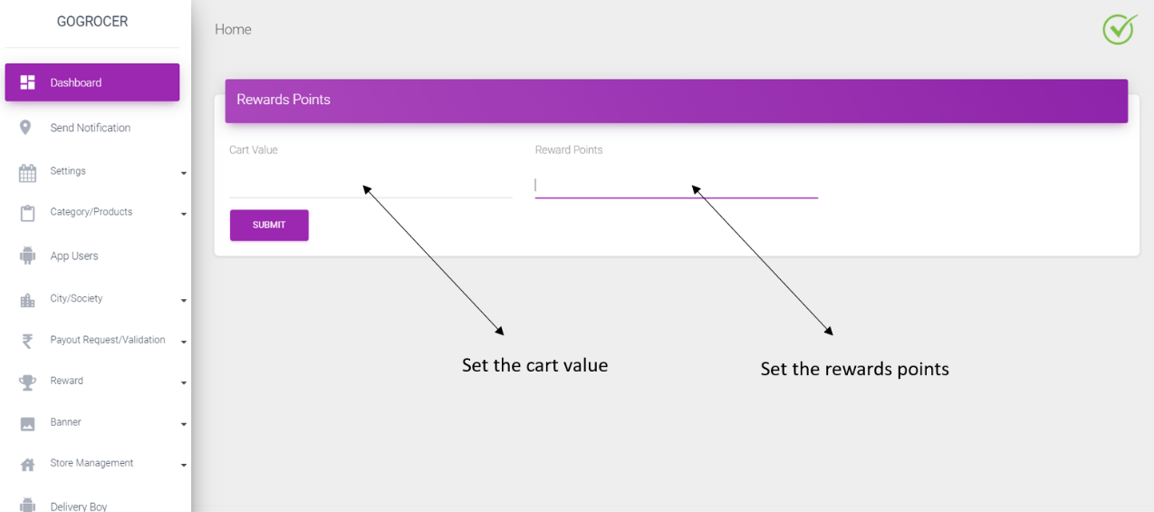

1. Redeem values

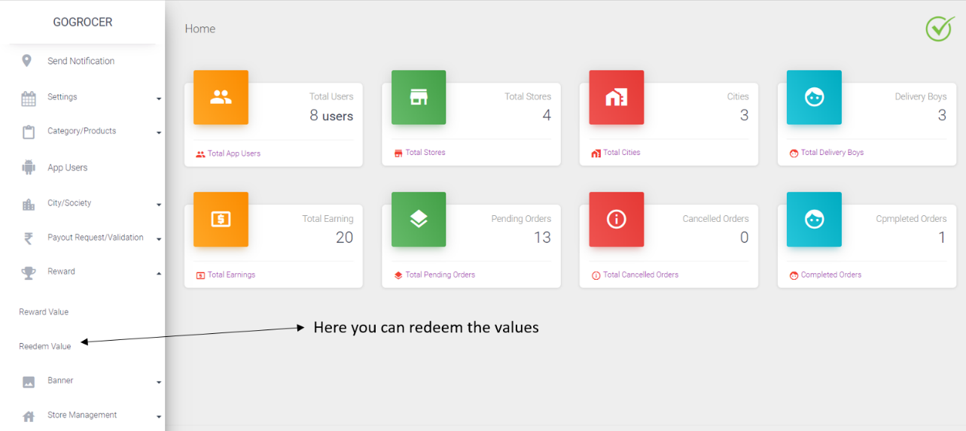  
Here you can redeem the rewards points (for ex: 1 rewards points contain 0.25 value)

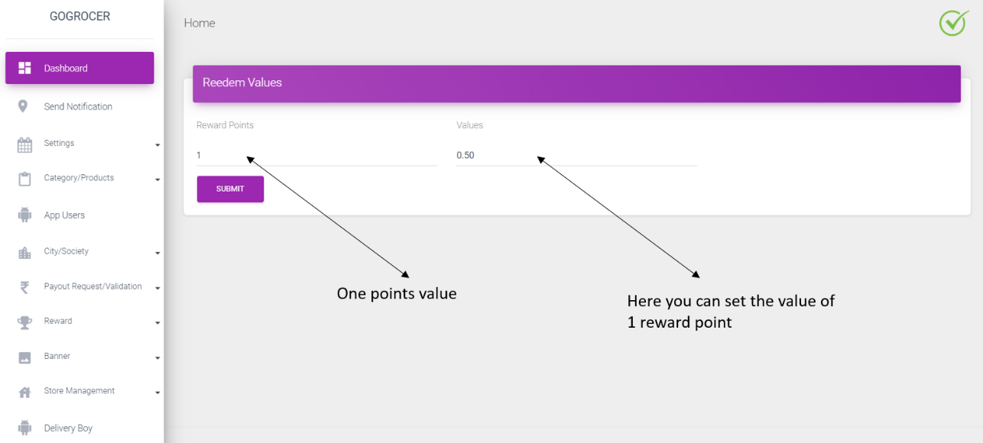

1. Min/ Max Order  
   In this section you can set the values of order Min. amount & Max. amount

